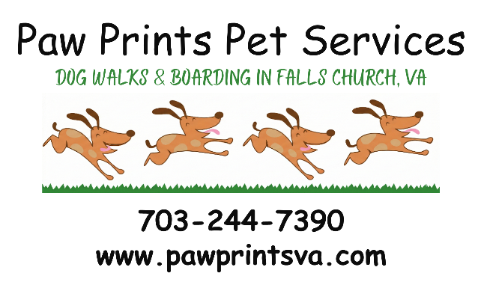
New Client Packet
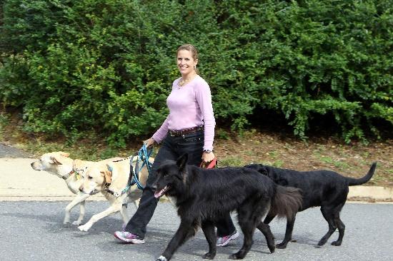
Thank you for choosing Paw Prints Pet Services!

The New Client Packet Includes:

- Service Agreement (sign and return)
- Veterinary Release Agreement (fill in emergency vet authorization amount, sign, and return)
- Key Handling Agreement (sign and return)
- Pet Information Form (one copy for each pet; each form is 3 pages, sign, and return)
- Contact Information Form (fill out and return)
- Service Request (fill out and print one for each trip or service period, sign, and return)
- Pet Lodging Addendum, if applicable (fill out and return)

At the initial interview (meet and greet):
- Your Pet Care Provider will meet your pet(s) to make sure they are comfortable having a visitor in the house.
- Review your pet care instructions and discuss any special situations or needs.
- Pick up 2 key copies. We will provide a key tag (your name or address will not be put on your key). It is important to have a backup key provided for an emergency, lost or broken key. Please test the keys to make sure they work.
- Review paperwork. All forms should be completed and signed before your first service. Please print legibly in ink.

We look forward to providing your pet with excellent care and many happy walks!


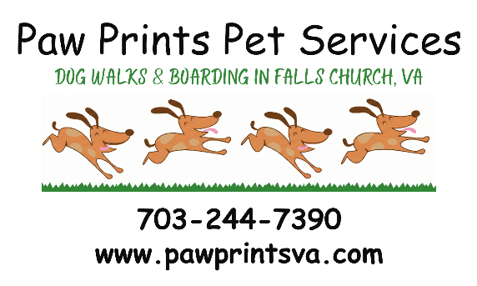


Suggested Leave-Out Checklist

- Copy of all forms, completed and Signed (if not provided previously)
- Collar and/or harness with dog’s name, rabies & registration tags
- Leash (we discourage retractable or flexi leashes)
- Waste bags
- Treats or chewies
- Muddy paw towels or rags
If applicable:
- Reminders & changes
- Plenty of food with instructions
- Favorite toys
- Paper towels & cleaning supplies
- Litter scoop & extra litter
- Medicines, plus instructions

Keys:
If you would like the Pet Care Provider to leave your key on the last visit, please leave a note reading “Leave Key” with the date as well as instructions on how to secure the house without the key. As a reminder, we will not be able to access your home for additional care in case of an emergency or delay in your return.

Contact Us:
Feel free to contact your Pet Care Provider to check up on your pets at any time. We try to return all calls the same day during our business hours of 8 AM – 8 PM. If you do not hear back from us within 24 hours, please try again – voice mails do sometimes get lost or emails go to spam.
Thank you for choosing Paw Prints Pet Services!
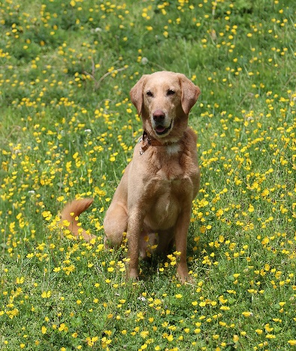
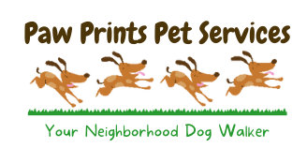
Jane Torok

2908 Westcott St Jane’s Cell: 703-244-7390
Falls Church, VA 22042 Email: pawprintpets@verizon.net
Web: www.pawprintsva.com
Follow us on Facebook: www.facebook.com/pawprintspetservices

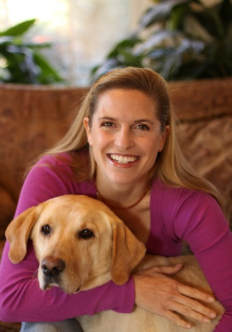

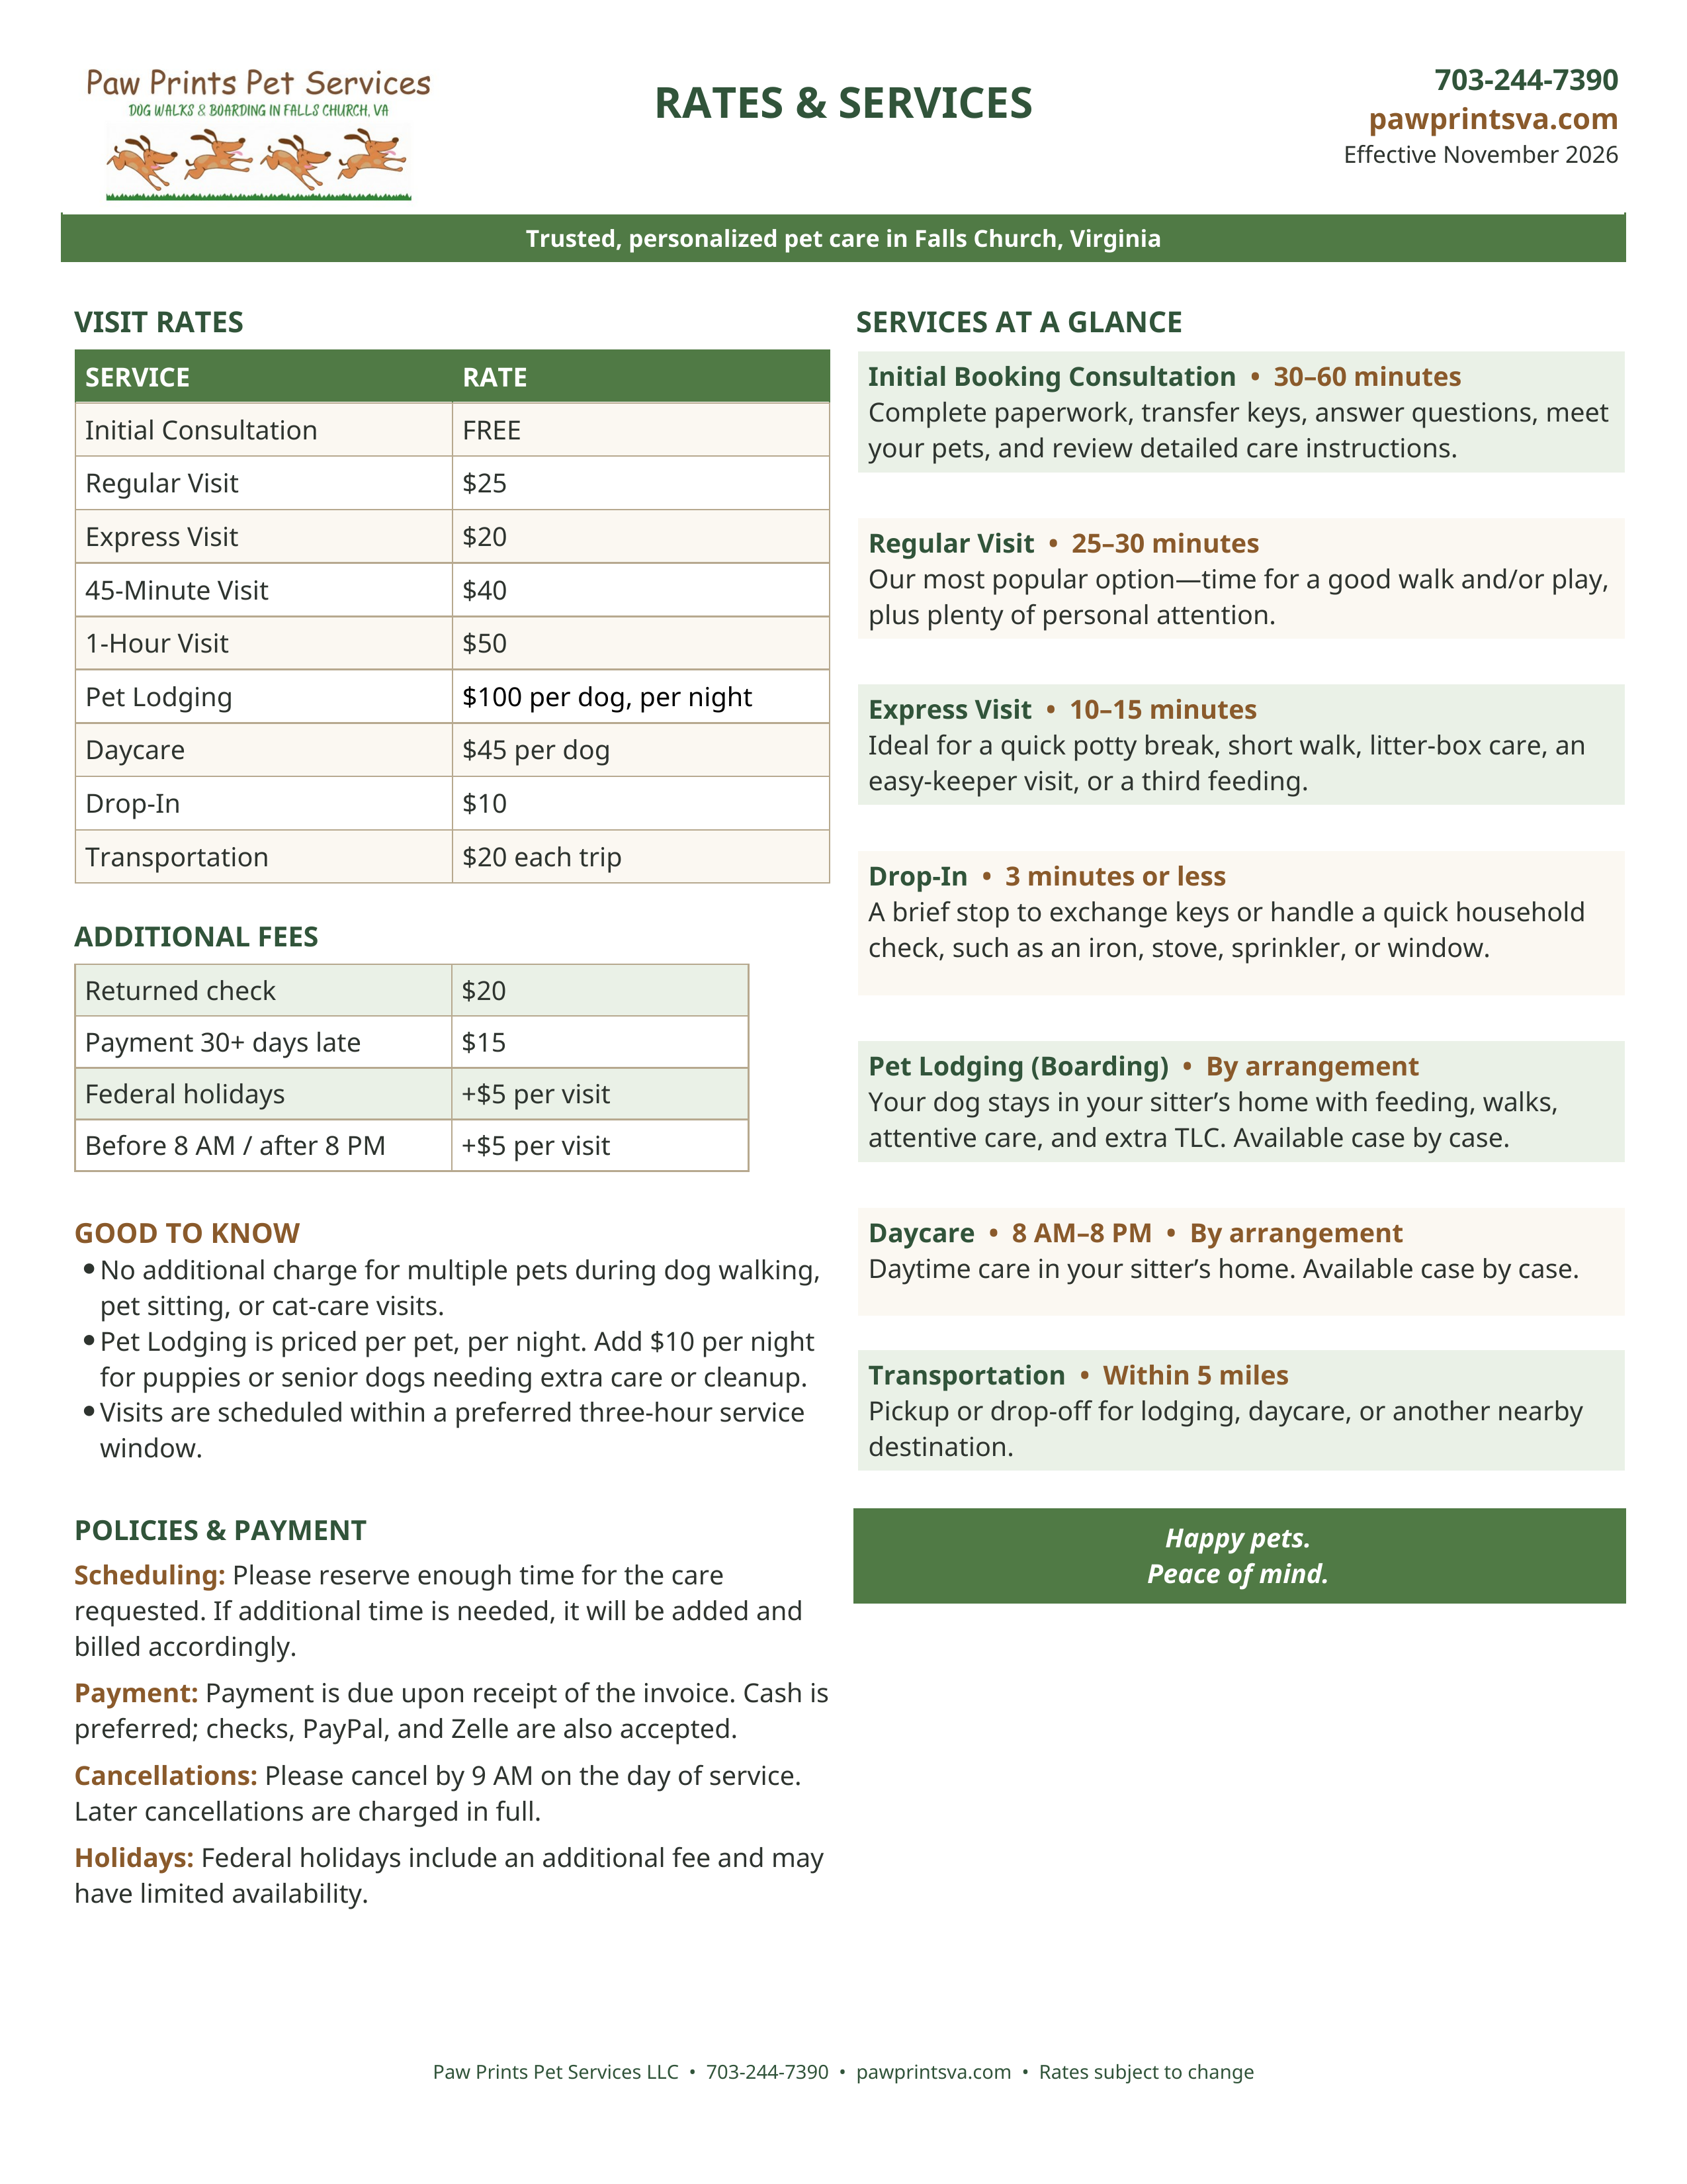
Paw Prints Pet Services LLC
Service Agreement

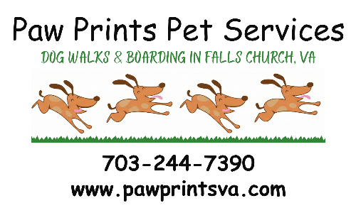
If any of my pets appears to be ill, injured, or at significant risk of experiencing a medical problem while in the care of Paw Prints Pet Services, I give permission to Paw Prints Pet Services to seek veterinary care from a veterinarian or a veterinary clinic. My preferred veterinary services are listed on the Pet Information Disclosure. However, I consent Paw Prints Pet Services to choose the veterinarian or emergency care clinic of its choice, at its discretion.

I ask Paw Prints Pet Services to inform the attending clinic or veterinarian of my requested total diagnosis and treatment limit of $_____________ per pet (most common values are $1,000 / $5,000 / $10,000 or unlimited). Please keep in mind, emergency vet care can be costly so choose a value that will allow for adequate treatment. Paw Prints Pet Services or its representatives will make every attempt to contact me and my emergency contact. However, I agree to allow Paw Prints Pet Services to use its best judgment in handling these situations. I understand that Paw Prints Pet Services and its representatives assume no responsibility for the actions and decisions of the veterinary staff for the health or death of my pet(s).

I will assume full responsibility for the payment and/or reimbursement for all veterinary services rendered, including but not limited to diagnosis, treatment, grooming, medication, medical supplies, and boarding. I understand and agree that I am 100% liable legally and financially for the Pet and the Pet’s actions at all times, and I assume all risks and liability related to the Pet and this Agreement. I will make such payments within 14 days of the initial incident. I also agree to be responsible for all additional service fees assessed by Paw Prints Pet Services such as, but not limited to, emergency transportation, care, supervision, or hiring of emergency caregivers and I will pay such fees within 14 days of each incident. I further authorize any veterinarian(s) who have provided or will provide services to my pet(s) to share all of the medical records of all of my animals with Paw Prints Pet Services and veterinary clinics in the interest of providing the best care possible to my pet(s).

I agree to notify Paw Prints Pet Services of any signs of injury or possible illness before any care service as soon as the condition appears. Paw Prints Pet Services reserves the right to cancel service for a pet with a potentially infectious or contagious condition. Paw Prints Pet Services requires me to provide my pet(s) with the appropriate standards of care and to be vaccinated, dewormed, and protected from harmful insects and parasites according to veterinarian recommended standards.

This agreement is valid from the date the Client signs this Agreement and grants permission for future veterinary care without the need for additional authorization each time Paw Prints Pet Services cares for one or more of my pets. I understand that this agreement applies to all of the pets within Paw Prints Pet Service’s care. Please provide a copy of this Veterinary Release form to your primary veterinarian to keep on file along with your current credit card information.

Client’s Printed Name: ___________________________________

Signature: _______________________________ Date: ____________

PAW PRINTS PET SERVICES LLC

BY: Jane Torok, Member/Manager
Signature: _______________________________ Date: ____________
Paw Prints Pet Services LLC  Veterinary Release Agreement | 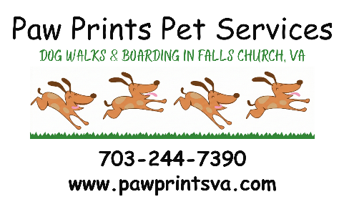

If any of my pets appears to be ill, injured, or at significant risk of experiencing a medical problem while in the care of Paw Prints Pet Services, I give permission to Paw Prints Pet Services to seek veterinary care from a veterinarian or a veterinary clinic. My preferred veterinary services are listed on the Pet Information Disclosure. However, I consent Paw Prints Pet Services to choose the veterinarian or emergency care clinic of its choice, at its discretion.

I ask Paw Prints Pet Services to inform the attending clinic or veterinarian of my requested total diagnosis and treatment limit of $_____________ per pet (most common values are $1,000 / $5,000 / $10,000 or unlimited). Please keep in mind, emergency vet care can be costly so choose a value that will allow for adequate treatment. Paw Prints Pet Services or its representatives will make every attempt to contact me and my emergency contact. However, I agree to allow Paw Prints Pet Services to use its best judgment in handling these situations. I understand that Paw Prints Pet Services and its representatives assume no responsibility for the actions and decisions of the veterinary staff for the health or death of my pet(s).

I will assume full responsibility for the payment and/or reimbursement for all veterinary services rendered, including but not limited to diagnosis, treatment, grooming, medication, medical supplies, and boarding. I understand and agree that I am 100% liable legally and financially for the Pet and the Pet’s actions at all times, and I assume all risks and liability related to the Pet and this Agreement. I will make such payments within 14 days of the initial incident. I also agree to be responsible for all additional service fees assessed by Paw Prints Pet Services such as, but not limited to, emergency transportation, care, supervision, or hiring of emergency caregivers and I will pay such fees within 14 days of each incident. I further authorize any veterinarian(s) who have provided or will provide services to my pet(s) to share all of the medical records of all of my animals with Paw Prints Pet Services and veterinary clinics in the interest of providing the best care possible to my pet(s).

I agree to notify Paw Prints Pet Services of any signs of injury or possible illness before any care service as soon as the condition appears. Paw Prints Pet Services reserves the right to cancel service for a pet with a potentially infectious or contagious condition. Paw Prints Pet Services requires me to provide my pet(s) with the appropriate standards of care and to be vaccinated, dewormed, and protected from harmful insects and parasites according to veterinarian recommended standards.

This agreement is valid from the date the Client signs this Agreement and grants permission for future veterinary care without the need for additional authorization each time Paw Prints Pet Services cares for one or more of my pets. I understand that this agreement applies to all of the pets within Paw Prints Pet Service’s care. Please provide a copy of this Veterinary Release form to your primary veterinarian to keep on file along with your current credit card information.

Client/Owner Printed Name: __________________________________

Client Signature: _______________________________ Date: ___________

Paw Prints Pet Services LLC  Key Handling Agreement | 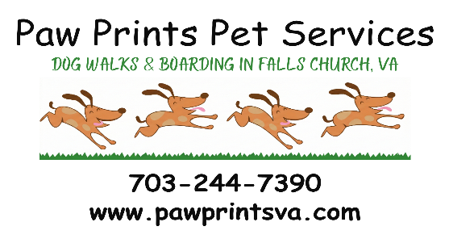

I have provided Paw Prints Pet Services with a key(s), FOB, or door code to enter my home for pet care services.

I furthermore agree to and understand the following conditions and terms:
- Paw Prints Pet Services requests two copies of all necessary key(s) to access my property and pet(s). It is important to provide a backup key(s) in case of an emergency, lost, or broken key. Paw Prints Pet Services has my permission to make a copy of my key(s) for emergency/backup purposes at its discretion.
- Client expressly gives Paw Prints Pet Services the authority to employ a locksmith on their behalf and to promptly reimburse Company for all costs incurred in the event of a malfunction of the lock, keys, FOB, or automatic door opener.
- Paw Prints Pet Services will place an identifying code on Client keys. The keys will not be marked with the Client’s name or address. When not in use or prepared for use, Paw Prints Pet Services will store the keys in a secure location.
- Paw Prints Pet Services will automatically retain client keys at the end of each service period unless otherwise requested. Paw Prints Pet Services will place the key in a secure location until future service is required. Paw Prints Pet Services will remove all identifying marks and tags and discard any keys that have not been used or returned after two or more years.
- Paw Prints Pet Services has permission to provide my keys to any of its employees, representatives, or independent contractors who will be providing service.

Key Returns
- I understand that if I prefer to have my key returned after the last pet care service visit, I will leave instructions on how to secure my home while leaving the key. I understand that Paw Prints Pet Services will not be able to access my house again after Paw Prints Pet Services has left the key, including in case of an emergency or delay in my return.
- Paw Prints Pet Services is willing to exchange keys via drop off or pick up or through the US Postal Service. If a separate visit to Client or US Postal Service is required for key pick up/drop off, Paw Prints Pet Services will charge me $10 for expenses, time, and travel fees.

By signing below, I agree to all terms as stated above.

Client/Owner Printed Name: ______________________________________

Client Signature: _______________________________ Date: ___________

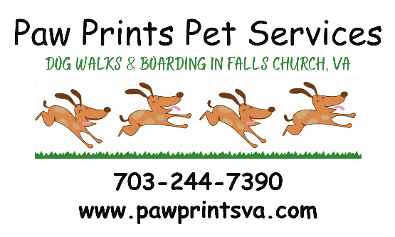
Paw Prints Pet Services LLC

Contact Information

Home Address:

____________________________________ Home Alarm instructions:

____________________________________ __________________________________________

Owner / primary contact
First & Last Name | Phones | Type | Email Addresses | Uses
 | ______________________  _____________________  ______________________ | Cell  Work  Home |  | All  Questions  Billing email  Emergency
 | ______________________  _____________________  ______________________ | Cell  Work  Home |  | All  Questions  Billing email  Emergency

Emergency contacts

Choose 2 trusted emergency contacts, preferably one who can make medical and care decisions for your pet, and another contact who is nearby, ideally with access to your home.
First & Last Name | Phones | Type | Email Addresses | Relationship & Location
 | ______________________  _____________________  ______________________ | Cell  Work  Home |  | has access to your home
 | ______________________  _____________________  ______________________ | Cell  Work  Home |  | has access to your home

Additional Comments:
Paw Prints Pet Services LLC  Pet Information Form | 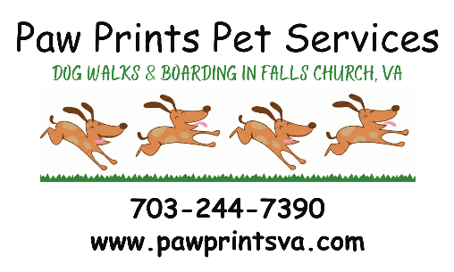

Please complete one Pet Information Disclosure form per pet or litter.

Owner: Pet Name:
Physical Description: (if similar to another) Pet Type: Dog / Cat / Other /
Breed:
Neutered Y / N Sex: M / F Birth date: Or Age:
Microchip: Y / N Declawed (cats): Y / N Weight: Or Size:
Emergency Care: *Placing Veterinary Release Agreement & Credit Card on file at vet’s office is recommended
 | Primary/Preferred Vet’s office | Secondary/Emergency Vet
Name:
Phone:
Address:
Primary Vet
Misc/Notes

Flea & tick treatment date: Last vaccination date:

Pet Health Insurance Coverage: Yes / No
Company: Policy #
Contact information:

Pet Medical History: (ongoing or reoccurring known illnesses/injuries, treatments & medications)

Pet Allergies:

Allergy Treatment:

Food or Treat Restrictions:

Owner: Pet:

Temperament/Personality:
Pet Doesn’t Like:
Baths Hot Days Loud Noise / Vacuum / Garbage Disposal
Toenail Clip Rain Thunder Being Left Alone
Massage Cold / Snow Fireworks (other)_________________
Touch Ears Other family pets All Humans (other)_________________
Strangers Other dogs Car rides (other)_________________
New Animals People near food dish Vet’s office (other)_________________

Pet reacts to the above by:

Has Pet Ever: Describe: (please be truthful!)

Attacked someone/bit someone
Attacked another animal
Injured self /escaped out of fear
Injured self out of boredom
Escaped from home
Where does he/she like to escape to?
How can he/she be retrieved?
Training Comments:

Favorite Games, Toys, and Activities:
Preferred walking equipment: collar harness halter other: _______________
Friendly with other dogs: Yes / No, explain ______________________ Friendly with children: Yes / No
Most likely to have accidents When: __________________________ Where: ___________________
Poop / waste disposal: outdoor garbage can separate garbage can other __________________
Pet’s sleeping area: pet bed owner’s bed crate other __________________
Pet’s Living Area:
NOT allowed outdoors  ONLY allowed outdoors on leash*  Turn out, invisible fenced yard  Turn out, secure fence  Turn out, no fence at home (at your risk)  Turn out, no fence for Farm Adventures*  ONLY allowed on leash Farm Adventure  NOT allowed indoors | Allowed on furniture, counters, beds  Restrict pet area/crate when pet is alone  Restrict pet area/crate at all times  Restricted Area/Crate Location:  Other off-limit areas:
*Farm Adventures will usually be off leash, pets allowed outdoors with no leash or fence will waive liability
Owner: Pet:
Water dish location:
Fill From Tap Use bottled water Fill from filtered sink faucet Fill from fridge door

Feeding Instructions: Recycle cans Dispose of uneaten food Store extra in fridge
Feed separated Remove food after _____ minutes

 | Morning | Mid Day | Evening | Other
Dry
Brand:
Amount:
Where to feed:
Special Instructions:
Wet
Brand:
Amount:
Where to feed:
Special Instructions:
Meds/Medical
Name:
Amount:
Location:
Frequency:
Procedure:
Meds/Medical
Name:
Amount:
Location:
Frequency:
Procedure:
Treats/Chewies
Name:
Amount:
Location:
Procedure:
Litter Box/Yard
Scoop Location:
Bags to be found in:
Dispose In:

Any other special instructions or notes for pet’s care or temperament:

Client/Owner Printed Name: _____________________________________

Signature: _______________________________ Date: ____________

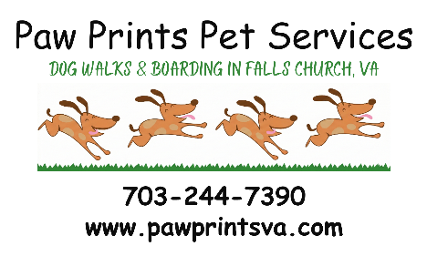
Paw Prints Pet Services LLC

Service Request

Client / Owner Name:

Pets needing care:
Date request created:

Schedule
Date service begins: / / 1st Visit Timing: __________ Daily Every other day Other
Date service ends: / / Last Visit Timing: ________ Payment method: Payment date:
On-going walks: Monday Tuesday Wednesday Thursday Friday
Saturday Sunday
*Service visits requested before 8 AM or after 8 PM will incur an additional $3 per visit after-hours fee
Details | Visit Time | Visit Length | Rate | # of Visits |  | Total
Morning * | 8 AM – 11 AM | 15 / 30 / |  | X | =
Afternoon | 11 AM – 3 PM | 15 / 30 / |  | X | =
Evening | 4 PM – 8 PM | 15 / 30 / |  | X | =
Night * | 8 PM – 10 PM | 15 / 30 / |  | X | =
Flexible | 8 AM – 8 PM | 15 / 30 / |  | X | =
Boarding | N/A | N/A |  | X | =

Tasks
Walk dog(s) | Bring in mail
Yard visit for dog | Take out trash
Clean litter boxes | Trash day ________
Feed pet(s) | Water Plants
Medications
Injections
Visit Status Update Preferences:
once a day each visit no updated needed

written log text update

Additional Notes:

This request must be confirmed by Paw Prints Pet Services. Visits are subject to availability. By submitting this request, I (the Client) agree to all terms as stated on the Legal Considerations Agreement, Veterinary Release and Key Handling Agreements, any other signed forms, and on the Service Provider’s website.

Client Printed Name: ____________________________

Client Signature: ______________________________ Date: ___________

